TECHNICAL TRAINING

Undergraduate Cyber Warfare Training

Introduction to Cyber Fundamentals

STUDENT HANDOUT

15 Jun 2021


81ST TRAINING GROUP
333D TRAINING SQUADRON
Keesler AFB, MS

Foreign Disclosure: The information in this document is not restricted and may be disclosed to international students.
Refer to the foreign disclosure memorandum in the security annex of the Course Training Plan for further information.

Table of Contents

Exercise I – Patch and Map the Network 1
Exercise II – Initial Configuration 3
Exercise III – Secure Remote Access 9
Exercise IV - Dynamic Trunking Protocol (DTP) 11
Exercise V– VLAN Trunking Protocol (VTP) 14
Exercise VI – Virtual Local Area Networks (VLAN) 16
Exercise VII – Spanning Tree Protocol (STP) 18
Exercise VIII – Port Security 19
Exercise IX – Switched Virtual Interface (SVI) 22
Exercise X – Implement Sub-interfaces 24
Exercise XI – Router Interface Configuration 26
Exercise XII – Enhanced Interior Gateway Routing Protocol (EIGRP) 27
Exercise XIII – Access Control Lists (ACLs) 29
APPENDIX A – Download Packet Tracer for Home Use 31
APPENDIX B – Network Diagram 32

STEPS TO ACCESS PACKET TRACER

    - Login to the Workstation
Username: StudentXX (Where XX = your student #)
Password: StudentXX (Where XX = your student #)

    - From the Desktop
- Open the Block 5 Folder\Block 5 Labs\Workbook\Block V – Workbook Exercise.pkt

STEPS TO INTERACT WITH AN ASSET

- Click on the switch

- Click on the CLI (Command Interface) tab

Exercise I – Patch and Map the Network

DIRECTIONS: Using Cisco Patch Tracer, patch your devices, in accordance with the network diagram provided. Once all patches are complete, map out the entire network via the command line.

GOALS:
  - Patch network
  - Map network

STEPS:

- In the bottom, left hand corner of the application click on the lightning bolt icon
- Select the dotted black line – This line represents a cross over cable (screenshots below)
- To patch your network devices:
- Click on the device and assign it an interface
- Drag the line to the second device and assign it to an interface
- Patch all network devices to match the provided network diagram
- Using the default configurations for the network devices, utilize the Cisco Discovery Protocol to map the network.

Device ID Local Intrfce Holdtme Capability Platform Port ID

Switch Fas 0/1 122 S 2960 Gig 0/1

Switch Fas 0/2 176 S 2960 Gig 0/1

Switch Fas 0/3 149 S 2960 Gig 0/1

Switch Fas 0/10 162 3560 Fas 0/10

Device ID Local Intrfce Holdtme Capability Platform Port ID

Switch Fas 0/1 179 S 2960 Gig 0/2

Switch Fas 0/2 174 S 2960 Gig 0/2

Switch Fas 0/3 146 S 2960 Gig 0/2

Switch Fas 0/10 160 3560 Fas 0/10

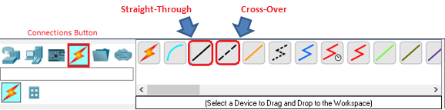

3560

fX-3560# show cdp neighbors

- Compare your findings between your distribution switches and determine the big picture outlook.

F1
Device ID Local Intrfce Holdtme Capability Platform Port ID
Switch Fas 0/1 153 S 2960 Gig 0/1
Switch Fas 0/2 148 S 2960 Gig 0/1
Switch Fas 0/3 120 S 2960 Gig 0/1
Switch Fas 0/10 134 3560 Fas 0/10

F2
Device ID Local Intrfce Holdtme Capability Platform Port ID
Switch Fas 0/1 153 S 2960 Gig 0/1
Switch Fas 0/2 148 S 2960 Gig 0/1
Switch Fas 0/3 120 S 2960 Gig 0/1
Switch Fas 0/10 134 3560 Fas 0/10

- How many devices make up the network?
- Identify each network device’s hardware platform and the Internetwork Operating System (IOS) version.

3560

fX-3560# show cdp neighbors detail

2960s - 12.2(25)FX

3560s - 12.2(37)SE1

Exercise II – Initial Configuration

OBJECTIVES

Using Cisco Packet Tracer and classroom reference materials, connect, configure and administer networking devices in accordance with the provided network map.

- Layer 1 and Initial Configurations (CISCO ICND 100-105: 6, 7)
- Layer 2 Configurations (CISCO ICND100-105: 9, 11 – 12; ICND200-105: 1, 2, 5)
- Layer 3 Configurations (CISCO ICND100-105: 8, 18, 25 -26; ICND200-105: 6-11, 16-17, 19-21, 25-26)

DIRECTIONS: Using the provided reference material, complete the initial configuration for each network device.

GOALS:
  - Hostname
  - Passwords
  - Banner
  - IP domain
  - Timestamps
  - Management interface and IP address assignment
  - Save all configurations

*NOTE: The examples used are NOT intended for your equipment verbatim; substitute your floor#, 2911, 2960, or 3560 for the numbers listed as necessary.

    - Configure the hostname for each network device.
Name the devices according to the network diagram.

ALL DEVICES

switch>enable
switch#configure terminal
switch(config)# hostname <name> (note: the hostname will immediately change once the command is entered)

    - Configure the enable secret password. Use warrior for this password.

ALL DEVICES

fX-XXXX(config)# enable secret warrior
fX-XXXX(config)# end

CHECK CONFIGURATION

**The “show run” command will show you the current configuration of your device. This will be one of your most valuable commands. Press “enter” or “space bar” to expose more of the running configuration. Based on the above commands you will see following output. Please note that the hostname will be different for each device.**

f1-2960#show run

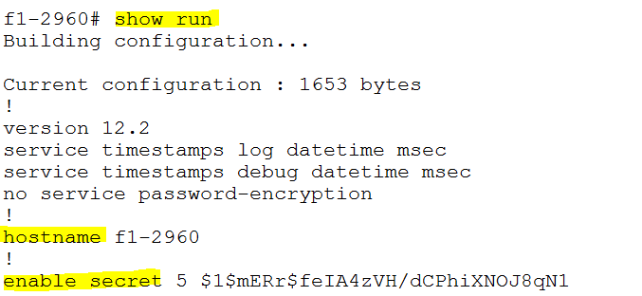

NOTE: The enable secret password is encrypted in the “show run” output.

ERROR CORRECTION
ALL MISTAKES CAN BE FIXED! If you made a mistake with the hostname, go back to configuration mode and type no hostname, then type hostname <correct hostname>. The NO command in front of a configuration command, will delete it from the device. You can then re-run the correct command to fix any mistakes you made.

    - Configure the banner. This is typically a standard DoD warning banner that is displayed during a DoD system login. Use the following message as the banner:

You are accessing a U.S. Government (USG) Information System (IS) that is provided for USG-authorized use only. You have read & consent to terms in the IS user agreement.

ALL DEVICES

fX-XXXX(config)# banner motd (delimiting character) (type message) (same delimiting character)

*** NOTE: A delimiting character must be the same at the beginning and end. The special character can be a character not used in the message itself. *** (highlighted double quotes are the delimiting character in the example below)

ERROR CORRECTION
ALL MISTAKES CAN BE FIXED! If you made a mistake with the banner, go back to configuration mode and type “no banner motd”, then type banner motd correct banner. The NO command in front of a configuration command, will delete it from the device. You can then re-run the correct command to fix any mistakes you made.

    - Configure the IP domain-name and disable the IP domain name lookup function. Use the domain name for the devices according to the instructional supplement.

ALL DEVICES

fX-XXXX(config)# ip domain-name <domainname>
fX-XXXX(config)# no ip domain-lookup

    - Configure the service timestamps.

ALL DEVICES

fX-XXXX(config)# service timestamps log datetime msec
fX-XXXX(config)# service timestamps debug datetime msec

CHECK CONFIGURATION
Remember to hit “enter” or “space bar” after executing a show run to get to the configuration of interest
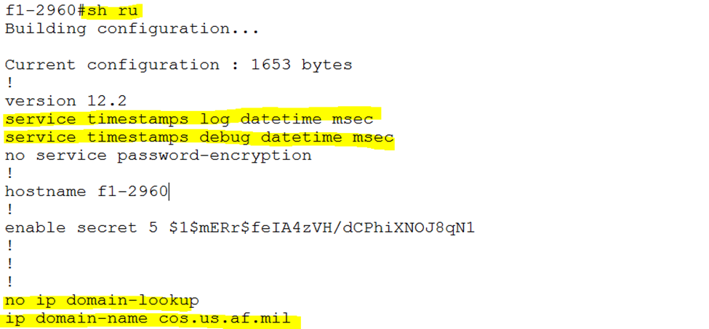

    - Configure the console port settings and password to enable login capabilities. Use the password provided below for login and set the inactivity timeout. Then enable the logging synchronous option.

ALL DEVICES

fX-XXXX(config)# line console 0
fX-XXXX(config-line)# password cyber
fX-XXXX(config-line)# login
fX-XXXX(config-line)# exec-timeout 5
fX-XXXX(config-line)# logging synchronous

CHECK CONFIGURATION
Remember to hit “enter” or “space bar” after executing a show run to display the running configuration either by line or para

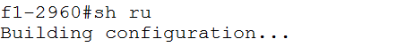

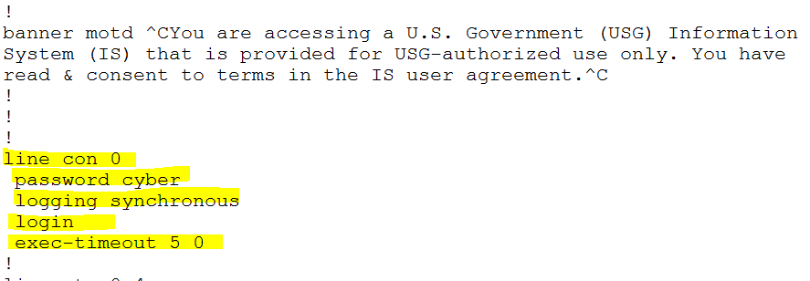

ERROR CORRECTION
ALL MISTAKES CAN BE FIXED! If you made a mistake with the console password, go back to configuration mode and type “line console 0”, then enter “no password”, then type password <correct password>. The NO command in front of a configuration command, will delete it from the device. You can then re-run the correct command to fix any mistakes you made.

    - Configure the management interface with an IP address. The default interface is VLAN 1. The device IP addresses are located on the instructional supplement (Y correlates to the last octet of the device’s host address). DO NOT CONFIGURE A VLAN ON THE ROUTERS. YOU WILL INSTEAD CONFIGURE A SUB-INTERFACE.

ALL SWITCHES

fX-XXXX(config)# interface vlan1
fX-XXXX(config-if)# ip address 192.168.1.Y 255.255.255.0
fX-XXXX(config-if)# description Management
fX-XXXX(config-if)# no shutdown

CHECK CONFIGURATION
Remember to hit “enter” or “space bar” after executing a show run to get to the configuration of interest

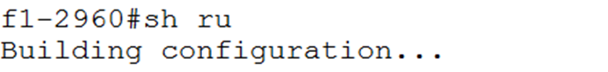

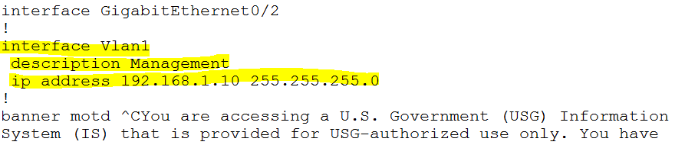

ERROR CORRECTION
ALL MISTAKES CAN BE FIXED! If you made a mistake with the IP address or subnet mask, go back to configuration mode and type “interface vlan1”, then type no ip address, then ip address <correct ip address subnet mask>. The NO command in front of a configuration command, will delete it from the device. You can then re-run the correct command to fix any mistakes you made.

2911s (ROUTERS)

fX-2911 (config)# interface GigabitEthernet0/0.1
fX-2911 (config-subif)# description Management
fX-2911 (config-subif)# encapsulation dot1q 1
fX-2911 (config-subif)# ip address 192.168.1.Y 255.255.255.0

CHECK CONFIGURATION
Remember to hit “enter” or “space bar” after executing a show run to get to the configuration of interest

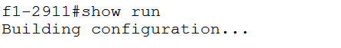

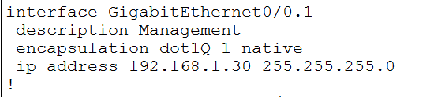

ERROR CORRECTION
ALL MISTAKES CAN BE FIXED! If you made a mistake with the IP address or subnet mask, go back to configuration mode and type “interface GigabitEthernet0/0.1”, then type no ip address, then ip address correct ip address subnet. The NO command in front of a configuration command, will delete it from the device. You can then re-run the correct command to fix any mistakes you made.

    - Test passwords for network devices. At this point, the configuration is not permanently saved. If there is a problem with a password, now is the time to discover it.

ALL DEVICES

fX-XXXX(config-if)# <CTRL> Z
fX-XXXX# exit
Press RETURN to get started! Press Enter
Password: cyber

fX-XXXX> enable
Password: warrior (the password is not visible as you type it)

*** NOTE: If this works, proceed to the next step. If it doesn’t, let the instructor know. ***

    - Save configurations!

ALL DEVICES

fX-XXXX# copy running-config startup-config
Destination filename [startup-config]? Press enter to accept default

Exercise III – Secure Remote Access

DIRECTIONS: Configure secure shell on all devices.

GOALS:

  - Create a user account and configure VTY lines to support secure shell access
  - Generate the RSA crypto key
  - Test the connection
  - Save configurations

STEPS:

    - Create a user account to access SSH. The user account name (student.adm) can be found on your instructional supplement and the password will be ducks.

ALL DEVICES

fX-XXXX(config)# username student.adm secret ducks

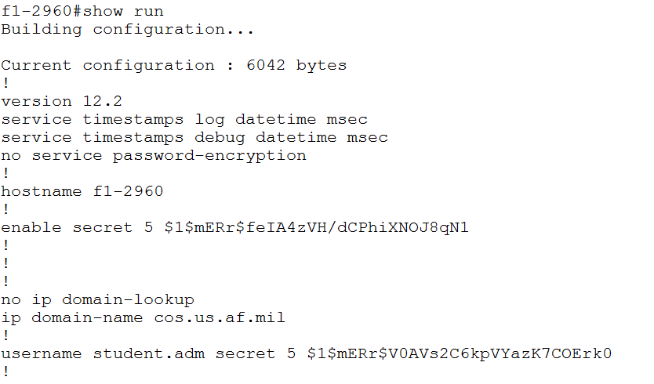

    - Configure virtual teletype/terminal (VTY) lines 0 through 15 to support SSH.

ALL DEVICES

fX-XXXX(config)# line vty 0 15
fX-XXXX(config-line)# login local
fX-XXXX(config-line)# exec-timeout 5
fX-XXXX(config-line)# logging synchronous
fX-XXXX(config-line)# transport input ssh
fX-XXXX(config-line)# exit

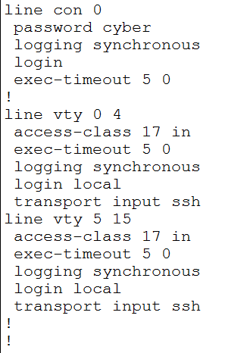

    - The next step to enable SSH is to generate the RSA crypto key.
Create the crypto key using 1024 size key modulus.

ALL DEVICES

fX-XXXX(config)# crypto key generate rsa

% You already have RSA keys defined named b#-xxxxxx.us.af.mil .
% Do you really want to replace them? [yes/no]: yes
Choose the size of the key modulus in the range of 360 to 2048 for your General Purpose Keys.
How many bits in the modulus [512]? 1024
Generating RSA keys…[OK].

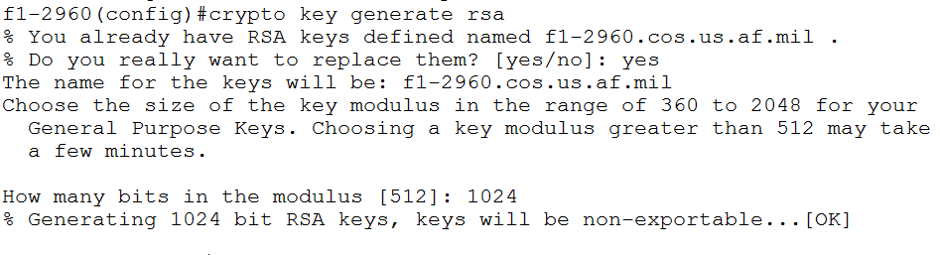

Currently you can SSH from one infrastructure device to another. In later exercises, once you establish IP connectivity between all devices, you will be able to SSH from your workstations to your infrastructure devices. (HINT) You can SSH to your devices on VLAN1 if you reconfigure PC0 to have an IP address on the management subnet and tag the switchport as VLAN 1 instead of VLAN 17.

3560

fX-XXXX# ssh –l student.adm ip-address

*NOTE: The character after the dash is an “L”.
Warrior

    - Save configurations!

Note: You can now access your assets utilizing SSH and the VLAN 1 IP address

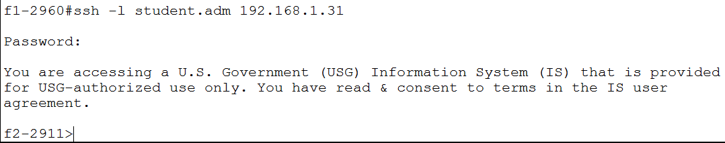
Exercise IV - Dynamic Trunking Protocol (DTP)

DIRECTIONS: Using the provided reference material, configure each layer 2 switch connection to use dynamic trunking protocol.

GOALS:

  - Layer 2 switch uplinks
  - Verify trunking operation
  - Save configurations

STEPS:

- Configure the layer 2 trunk connections for each network device. Also configure the description for each trunk with the name of the connected device (next hop). Replace the xx with the actual interface on the device. For example, interface GigabitEthernet0/01

3560s

fX-3560(config)# interface GigabitEthernet0/xx
fX-3560(config-if)# switchport trunk encapsulation dot1q
fX-3560(config-if)# switchport mode trunk
fX-3560(config-if)# description <device-name>

fX-3560(config)# interface FastEthernet0/xx
fX-3560(config-if)# switchport trunk encapsulation dot1q
fX-3560(config-if)# switchport mode trunk
fX-3560(config-if)# description <device-name>

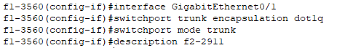

2960s
fX-2960(config)# interface GigabitEthernet0/xx
fX-2960(config-if)# switchport mode trunk
fX-2960(config-if)# description <device-name>

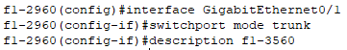

- Verify trunking operations.

ALL SWITCHES

fX-XXXX# show run
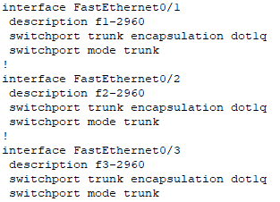

- Any switchport left turned on and un-configured leaves open holes in a network. Close all unused ports as a security measure. For switches only, place all unused ports into the SHUTDOWN VLAN. When using the range command, the xx-yy represents the range of actual interfaces on the device.

ALL SWITCHES

fX-XXXX(config)# interface range FastEthernet0/xx-yy
fX-XXXX(config-if)# switchport mode access
fX-XXXX(config-if)# switchport access vlan XX
fX-XXXX(config-if)# shutdown

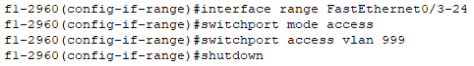

Remember to shut down your unused GigabitEthernet ports. For GigabitEthernet ports, use GigabitEthernet0/xx NOT FastEthernet0/xx).

fX-XXXX(config)# interface GigabitEthernet0/xx
fX-XXXX(config-if)# switchport mode access
fX-XXXX(config-if)# switchport access vlan XX
fX-XXXX(config-if)# shutdown

4. Save configurations!

Exercise V– VLAN Trunking Protocol (VTP)

DIRECTIONS: Using the provided reference material, configure VTP operations.

GOALS:

- Verify default VTP configurations
- Configure VTP domain
- Configure VTP mode
- Configure VTP version
- Save Configurations

STEPS:

- Verify default VTP configurations.

ALL SWITCHES

fX-XXXX# sh vtp status

What is the operating mode of your access switches? Distribution switches?
What is the VTP domain of your access switches? Distribution switches?
What is the VTP version of your access switches? Distribution switches?

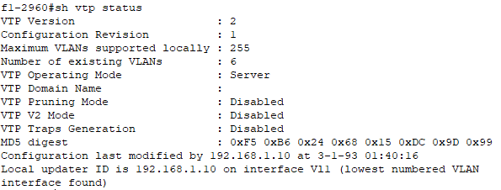
- Configure the VTP domain per the instructional supplement. Domain names are case sensitive.

ALL SWITCHES

fX-XXXX# conf t
fX-XXXX(config)# vtp domain name
fX-XXXX(config)# vtp password mad
What is the domain of the Floor 1 switches?

What is the domain of the Floor 2 switches?

What is the domain of the Floor 3 switch?

- Configure all access switches and the second floor distribution switch to client mode. Leave the first floor distribution switch (f1-3560) in the default server mode. Server mode is used to manage VLANs for the network. Client mode puts a switch into “listening” mode to match updates on the server. A third mode, transparent mode, would be used to allow a switch to operate VLANs and receive updates independently from the VTP server (directly from administrator) and not sync when the clients sync, but we will not be configuring that mode in this exercise.

ALL SWITCHES

fX-XXXX(config)# vtp mode server or client

5. Configure the VTP server to operate at VTP version 2. This can only be accomplished on the VTP server. VTP will then propagate this to the other switches.

3560

f1-3560(config)# vtp version 2

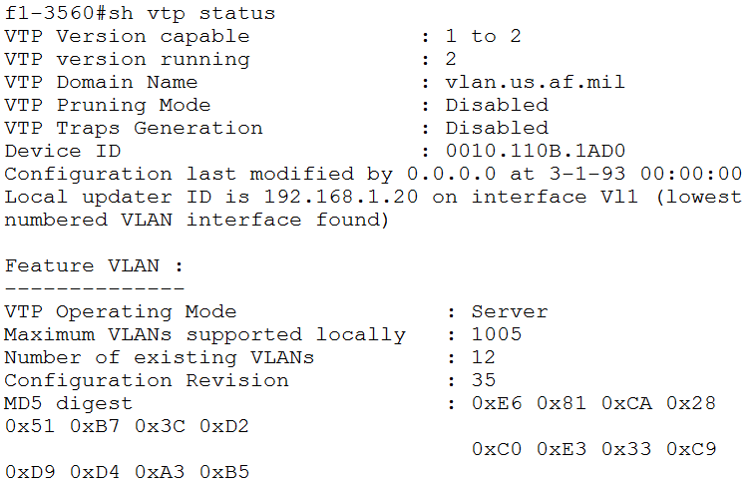

- Save configurations!

Exercise VI – Virtual Local Area Networks (VLAN)

DIRECTIONS: Create multiple VLANs within the pod, assign interfaces to those VLANs, and give descriptions for those interfaces.

GOALS:

- Create Layer 2 VLANs and names
- Verify VLAN creation and configurations
- Assign interfaces to the VLANs
- Save Configurations

STEPS:

- Create the layer 2 VLANs on the VTP server. Create the VLANs for the equipment per the table below. (XX correlates to the VLAN number created).

VLANs
VLAN # | NAME
17 | USERS
27 | PRINTERS
37 | SERVERS
47 | GCCS
57 | TBMCS
67 | VOIP
999 | SHUTDOWN

VTP SERVER

f1-XXXX(config)# vlan XX
f1-XXXX(config-vlan)# name <name>
f1-XXXX(config-vlan)# exit

(Use quotation marks whenever names have any spaces, e.g. “1 CMXS”.)

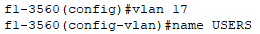

- Verify VLAN creation and configurations for all devices.

ALL SWITCHES

f1-XXXX# show vlan

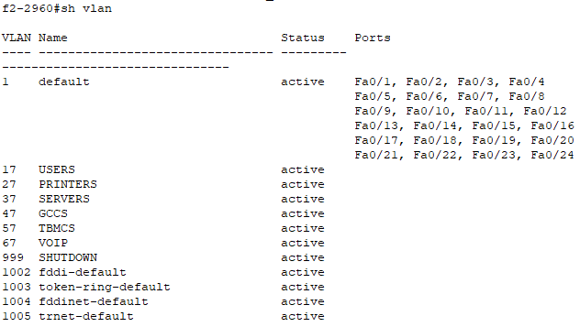

- Per the network diagram, assign each interface to the proper VLAN for the VLANs you have created. (zz is the actual physical interface on the 2960 switch)

ALL 2960s

f1-2960(config)# interface FastEthernet0/zz
f1-2960(config-if)# switchport access vlan XX
f1-2960(config-if)# switchport mode access

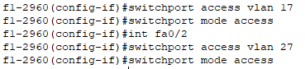

- Verify each interface is assigned to the correct VLAN.

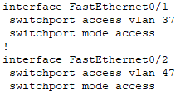

- Save configurations!

Exercise VII – Spanning Tree Protocol (STP)

DIRECTIONS: Using the provided reference material, verify and configure spanning tree protocol

GOALS:

- Configure STP root bridge changes
- Save all configurations

STEPS:

- Configure the floor 1 and 2 distribution switches to be the spanning tree “primary” or “secondary” root bridge based on the table below. Use a priority of 4096 to configure as primary and 8192 to configure as secondary. XX represents the VLAN ID.

3560s

fX-3560(config)# spanning-tree vlan XX priority <4096 or 8192>

FLOOR 1
PRIORITY 4096 | PRIORITY 8192
VLAN 1
VLAN 17 | VLAN 47
VLAN 27 | VLAN 57
VLAN 37 | VLAN 67

FLOOR 2
PRIORITY 4096 | PRIORITY 8192
 | VLAN 1
VLAN 47 | VLAN 17
VLAN 57 | VLAN 27
VLAN 67 | VLAN 37

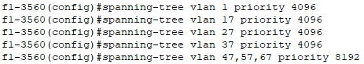

- Save configurations!

Exercise VIII – Port Security

DIRECTIONS: Using the provided reference material, configure port security. This will demonstrate how to restrict input to an interface by limiting and identifying MAC addresses of the workstations that are allowed to access each port.

GOALS:

- Configure port security on an interface.
- Test connectivity.
- Save configurations.

STEPS:

2960s

- Turn port security on for all interfaces except trunk interfaces. When using the range command, the xx-yy represents the range of actual interfaces on the device.

fX-2960(config)# interface range FastEthernet0/xx-yy

fX-2960(config-if-range)# switchport mode access

*NOTE (for interfaces not already in access mode)

fX-2960(config-if-range)# switchport port-security

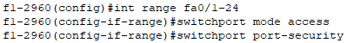

- Set the violation parameters for the interfaces.

fX-2960(config-if-range)# switchport port-security violation shutdown

- Set the maximum number of MAC addresses allowed to be associated with the interface.

fX-2960(config-if-range)# switchport port-security maximum 2

- Setting the interface to sticky mode will allow the interface to dynamically learn MAC addresses.

fX-2960(config-if-range)# switchport port-security mac-address sticky

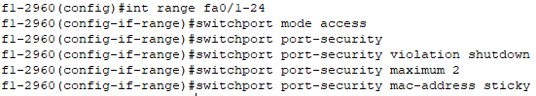

Now let’s trip port security!

- Let’s create a scenario by manipulating an end user device.

  - Click on PC0
  - Go to the Config tab
  - Click FastEthernet0 in the left hand column
  - Give PC0 the IP address of 129.13.17.15 and a subnet mask of 255.255.255.192. This is an unused host available on the USERS VLAN..

Check to see if the interface has learned your MAC

f1-2960# show port-security
f1-2960# show port-security interface FastEthernet0/1

Is this the MAC address of the PC you connected?

- Now change the MAC address of the PC
  - Click on PC0
  - Go to the Config tab
  - Click the FastEthernet0 in the left hand column
  - Change the MAC address of the PC to any valid MAC address

Review your CurrentAddr (Count)

f1-2960# show port-security

What # does the CurrentAddr (Count) show?
Was Port Security Tripped?
Why?

- Finally trip Port Security
  - Click on the PC
  - Go to the Config Tab
  - Click the FastEthernet0 button
  - Change the MAC address of the PC

What happened to the connection between your PC and your access switch?

- Now clear Port Security

2960

f1-2960# clear port-security all
f1-2960# configure terminal
f1-2960(config)# interface FastEthernet0/1
f1-2960(config-if)# shutdown
f1-2960(config-if)# no shutdown

- Now save your configurations

Exercise IX – Switched Virtual Interface (SVI)

DIRECTIONS: Using the provided reference material and the table listed below; configure (SVIs) in order to create a Layer 3 presence for the VLANs previously created.

GOALS:
- Configure SVI
- Save configurations
- Test connectivity

STEPS:

  - Configure an SVI for all VLANs listed in the table below. This is to be accomplished on the distribution switches ONLY. Use the Instructional Supplement VLAN names as a guide, using the VLAN name in the description field below.

Floor 1 |  | Floor 2
VLAN 17 | 129.13.17.4 | VLAN 17 | 129.13.17.5
VLAN 27 | 129.13.27.68 | VLAN 27 | 129.13.27.69
VLAN 37 | 129.13.37.100 | VLAN 37 | 129.13.37.101
VLAN 47 | 129.13.47.132 | VLAN 47 | 129.13.47.133
VLAN 57 | 129.13.57.4 | VLAN 57 | 129.13.57.5
VLAN 67 | 129.13.67.4 | VLAN 67 | 129.13.67.5

3560s

fX-3560(config)# int vlan xx
fX-3560(config-if)# description description
fX-3560(config-if)# ip address <ip-address> <subnet-mask>

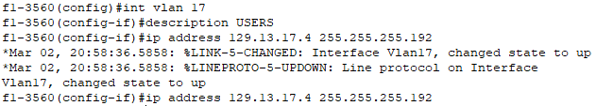

  - Verify SVI configuration. There are several commands to do this.

3560s

fX-3560# sh running-config
or
fX-3560# sh ip interface brief

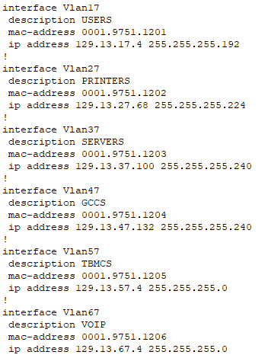

  - Verify SVI configurations.

  - Save configurations!

Exercise X – Implement Sub-interfaces

DIRECTIONS: Using the provided reference material, configure the sub-interfaces.

GOALS:

- Configure sub-interfaces for inter-VLAN routing using a Router-on-a-stick (RoAS) configuration
- Verify sub-interfaces
- Save configurations

STEPS:

- Turn the router’s physical interface that points toward the Distribution layer ON. The xx represents the actual interface on the device.

2911

fX-2911 (config)# interface GigabitEthernet0/xx
fX-2911 (config-if)# no shutdown

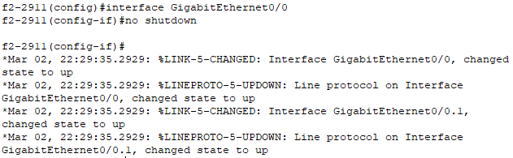

- Configure sub-interfaces for inter-VLAN routing. Each VLAN will have its own logical sub-interface configured on a router’s physical interface. The native VLAN, VLAN 1, should already have its sub-interface for Management traffic (exercise 2). The xx represents the actual interface on the device, and the zz is the VLAN ID.

2911

fX-2911 (config)# interface GigabitEthernet0/xx.zz
fX-2911 (config-subif)# description <vlan name>
fX-2911 (config-subif)# encapsulation dot1q zz
fX-2911 (config-subif)# ip address <ip address> <subnet mask>
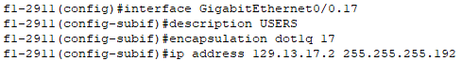

- Save configurations!

Exercise XI – Router Interface Configuration

DIRECTIONS: Using the provided reference material, configure your router interfaces with IP addresses. This will give your router interfaces the basic configuration needed to communicate and allow you to set up dynamic routing.

GOALS:

- Review current connectivity
- Enable routing
- Save configurations

STEPS:

- Configure the ISP and point-to-point (between 2911s) facing interfaces on the 2911s for IP traffic. The network and host address of each interface can be found in the instructional guidance for this workbook.

2911s

fX-2911 (config)# interface g0/y
fX-2911 (config-if)# ip address 130.20.100.x 255.255.255.252
fX-2911 (config-if)# description <ISP>
fX-2911 (config-if)# no shutdown
fX-2911 (config)# exit

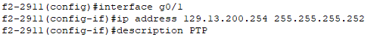

- Check that the interface IPs have been configured and have been entered properly.

2911

fX-2911# show run

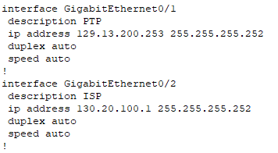

Exercise XII – Enhanced Interior Gateway Routing Protocol (EIGRP)

DIRECTIONS: Configure EIGRP. This provides EIGRP hands-on with various show commands.

GOALS:

- Configure EIGRP on network devices
- Test connectivity
- Save configurations

STEPS:

- Configure EIGRP on the core routers. The floor one and floor two routers will add network statements for the ISP and PTP connections.

*NOTE: Use the following configuration parameters.

ASN: Refer to the instructional supplement

Network: The network ID for all networks directly connected to the device. A network statement must be configured for every interface that is to participate in EIGRP.

Wildcard Mask: This is the inverse of the subnet mask.

2911

fX-2911 (config)# router eigrp <ASN>
fX-2911 (config-router)# network <network> <wildcard mask>
fX-2911 (config-router)# no auto-summary

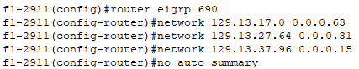

- View the routing table to see if any EIGRP routes were installed.
They are denoted by a D in front of them.

*NOTE: In EIGRP the ASN must be the same to allow network devices to actively participate and form neighbor relationships with each other.

What routes appear in your table?

- Test network connectivity utilizing ping. Ping the DNS server at 220.220.240.8 or the ISP router at 130.20.100.2, 130.20.100.6, or 220.220.240.1 from one of your core routers.

What, if anything, were you able to ping?

- View the routing table to see if any EIGRP routes were added or removed.

Are there any new routes? If so list them:

2911

fX-2911# show ip route eigrp or show run

2911

fX-2911# show ip eigrp neighbor

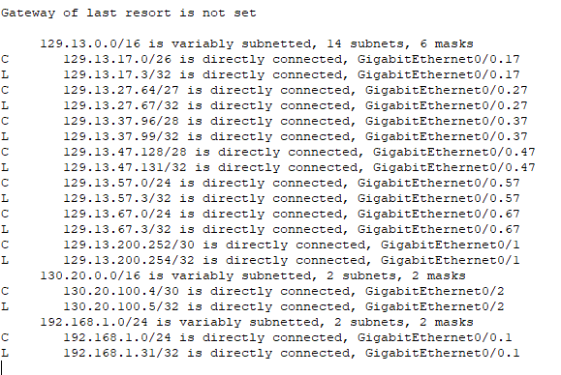

- Save configurations!

Exercise XIII – Access Control Lists (ACLs)

DIRECTIONS: Using the provided reference material, configure a standard and extended access control- list (ACL) and apply it to the necessary interface(s) for inbound traffic filtering.

GOALS:

- Build standard ACL and apply to interface
- Build extended ACL and apply to interface
- Save configurations

STEPS:

- Create a standard ACL to control access to virtual teletype/terminal lines (VTY) within the network. The first statement permits your ISP management server traffic. The second statement permits local management traffic.

ALL DEVICES

fX-XXXX (config)# ip access-list standard 17
fX-XXXX (config-std-nacl)# permit 220.220.240.8 0.0.0.0
fX-XXXX (config-std-nacl)# permit 192.168.1.0 0.0.0.255
fX-XXXX (config)# exit

- Apply ACL to INBOUND traffic on all VTY lines.

ALL DEVICES

fX-XXXX (config)# line vty 0 15
fX-XXXX (config-line)# access-class 17 in

- Create an extended ACL to allow management traffic (SSH // TCP/22) for remote administration from the ISP Management host (found on the instructional supplement). Block all other remote administration traffic [SSH], and let all other traffic pass.

2911s

fX-2911 (config)# ip access-list extended 109
fX-2911 (config-ext-nacl)# permit tcp 220.220.240.8 0.0.0.0 any eq 22
fX-2911 (config-ext-nacl)# deny tcp any any eq 22
fX-2911 (config-ext-nacl)# permit ip any any
fX-2911 (config)# exit

- Apply ACL to INBOUND traffic on the network interface facing the ISP.

2911s

fX-2911 (config)# interface GigabitEthernet0/2
fX-2911 (config-if)# ip access-group 109 in

- Verify configuration.

ANY DEVICE

fX-XXXX# show ip access-list <access list #>

- Save configurations.

APPENDIX A – Download Packet Tracer for Home Use

DIRECTIONS: Open an Internet browser and navigate to Cisco Network Academy and enroll, register, download, and install Packet Tracer for home use.

GOALS:
- Enroll in Cisco Network Academy
- Install Packet Tracer

STEPS:

- Navigate to Cisco Network Academy
  - Open an Internet browser
  - Navigate to https://www.netacad.com/courses/packet-tracer-download/

- Download Packet Tracer
  - Click the 'Enroll to Download Packet Tracer' button
  - Enroll in the Intro to Packet Tracer Course
  - Complete your Networking Academy registration
  - Launch the Intro to Packet Tracer Course
  - Download instructions are found within the course

- Load any of the UCT Block 5 Workbook or Practice PC Exercise .pkt or .pka files and begin configuring!

APPENDIX B – Network Diagram

